Web Application ISMS Security Control Validation Report

1.Introduction
This report presents the results of a security control validation performed on a web application, aligned with the principles of ISO/IEC 27001.
The objective of this assessment is to evaluate the effectiveness of implemented security controls, identify risks, and recommend mitigation strategies.

2. Scope of Assessment
- Target Application: Altoro Mutual
- Testing Type: Black-box testing
- Assessment Focus Areas:
a.Access Control
b.Data Protection (Encryption)
c.Asset Identification
d.Risk Management

3. Methodology
The assessment was conducted using a structured ISMS approach:
- Manual testing of authentication mechanisms
- Observation of data transmission methods
- Identification of application assets
- Risk assessment based on identified vulnerabilities
- Mapping findings to ISO 27001 control domains

4. Detailed Findings
4.1 Access Control (Weakness)
Control Domain: Access Control
Testing Performed:
- Multiple login attempts using weak credentials
- Repeated authentication attempts to simulate brute-force attack
Observation:
- No account lockout mechanism after multiple failed login attempts
- Absence of CAPTCHA or brute-force protection
- Weak authentication controls
Risk Level: High
Impact:
Attackers can gain unauthorized access through brute-force techniques
Recommendation:
- Implement account lockout policy
- Enforce strong password policies
- Enable Multi-Factor Authentication (MFA)
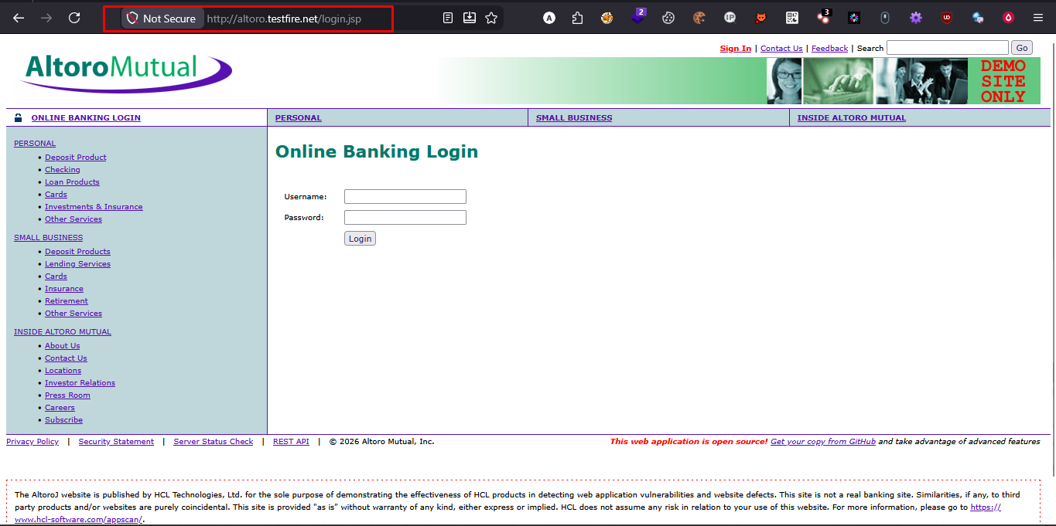
POC1:Login Page without any MFA or authentication system.

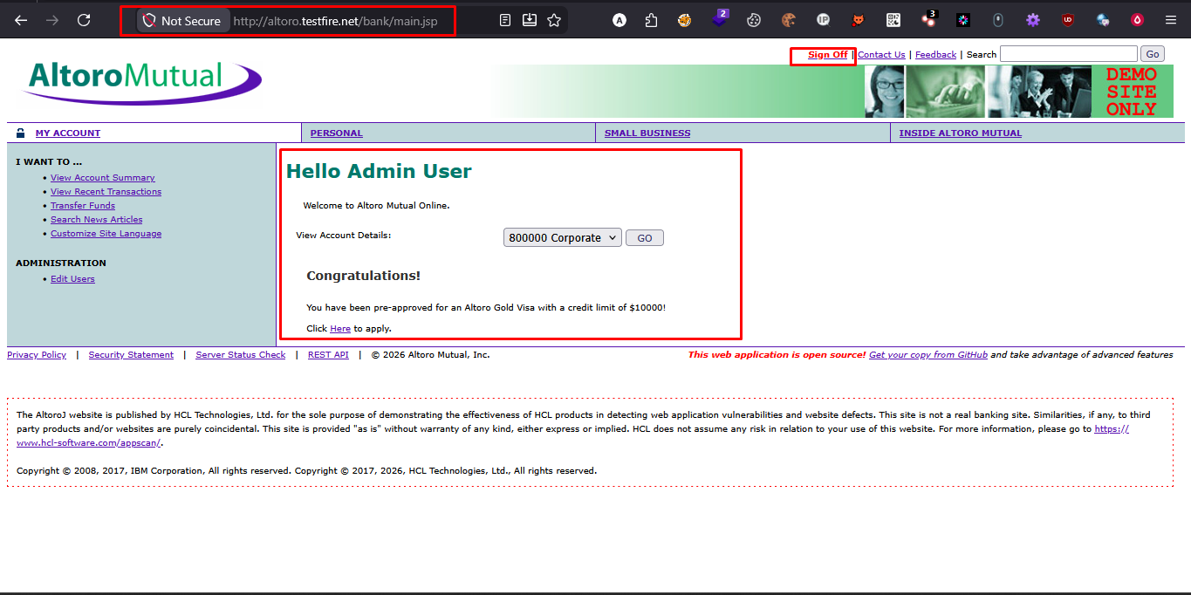
POC 2: Multiple login attempts using weak credentials but no lockout.
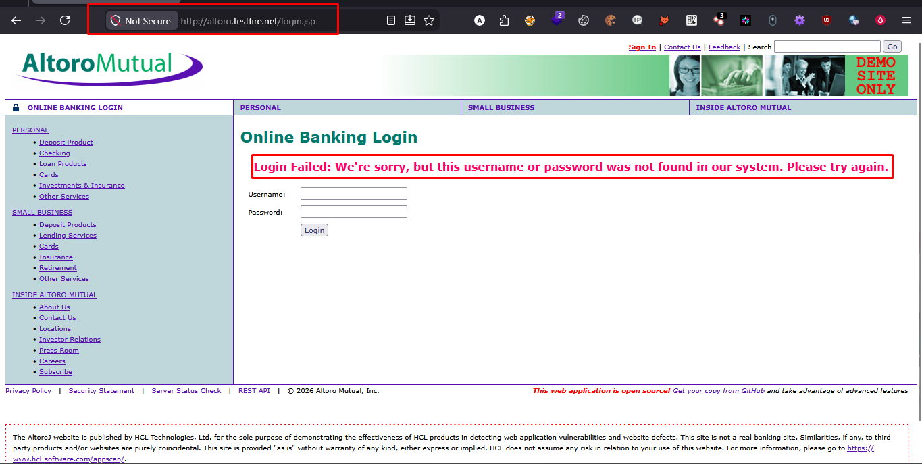
POC 3: Repeated authentication attempts to simulate brute-force attack

4.3 Asset Management Gaps
Control Domain: Asset Management
Identified Assets:
- Web Application Interface
- Backend Database
- User Credentials
Observation:
- No visible classification of assets
- Sensitive components exposed without restriction
Risk Level: Medium
Impact:
Unauthorized access to backend systems and data exposure
Recommendation:
- Define asset classification policy
- Restrict access to sensitive components
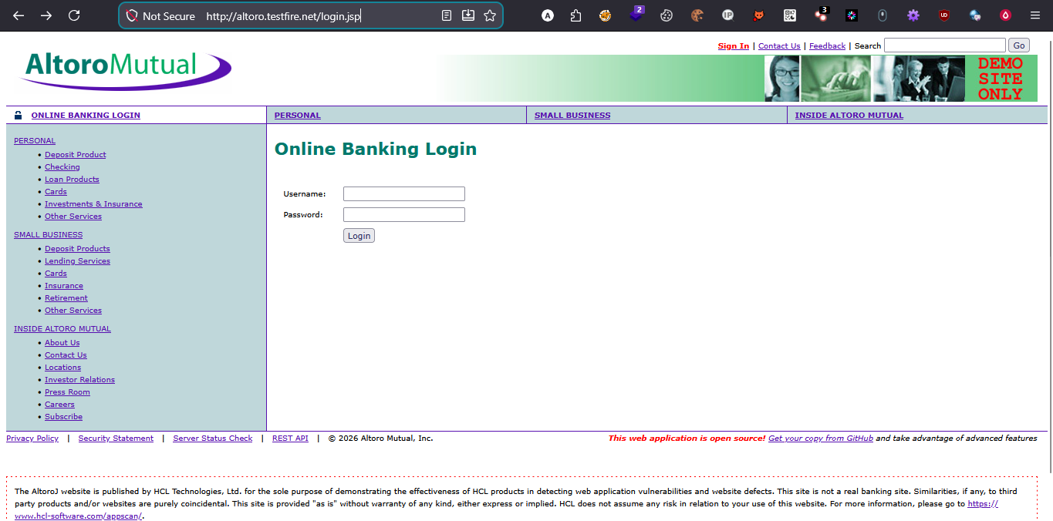

4.2 Lack of Encryption (HTTP Usage):
Control Domain: Cryptography / Data Protection
Observation:
- Application operates over HTTP
- Sensitive credentials transmitted in plain text
Risk Level: High
Impact:
Credentials can be intercepted using Man-in-the-Middle (MITM) attacks
Recommendation:
- Enforce HTTPS across the application
- Implement TLS encryption

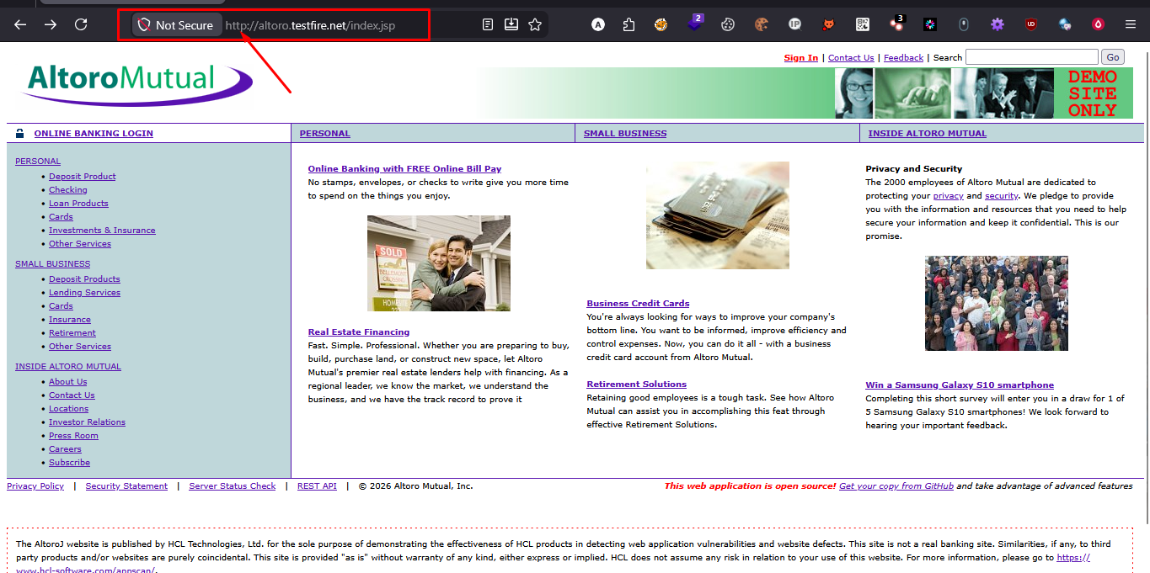
POC 1: Application operates over HTTP

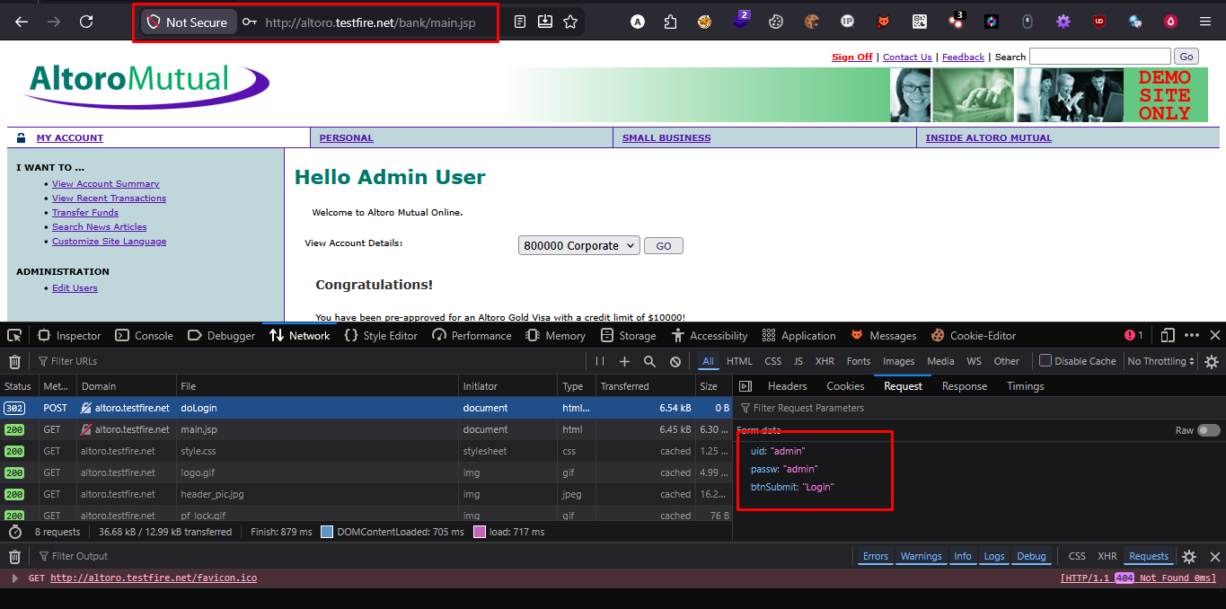
POC 2: Sensitive credentials transmitted in plain text

5. Risk Assessment

Asset | Threat | Vulnerability | Risk Level | Treatment
Login System | bruteforce | No Account Lockout | High | Implement lockout
Credentials | MITM Attack | No HTTPS | High | Enale SSL/TLS
Database | Data Theft | Weak authentication | High | Strengthen access control

6. Mapping to ISO 27001 Controls

Finding | ISO control area
Weak Authentication | Access Control
No HTTPS | Cryptography
Lack of Asset Visibility | Asset Managemen

7. Overall Risk Rating
High Risk
The application demonstrates critical security weaknesses in authentication and data protection mechanisms.

8. Key Recommendations
- Enforce strong authentication mechanisms
- Implement HTTPS across all endpoints
- Introduce asset classification and tracking
- Apply security best practices aligned with ISO 27001

9. Conclusion
The assessment identified multiple high-risk vulnerabilities affecting access control and data protection. Immediate remediation is required to align the application with ISO 27001 security standards and improve its overall security posture.

